1. Preparation of multimedia (logo, banner, animation/video)
2. Implementation of Home page and Product page
3. General

The overview of the home page:

HTML (Header)

一張含有 文字, 螢幕擷取畫面, 字型 的圖片

AI 產生的內容可能不正確。

The following is included in the page inside the <head> element.

* The external stylesheet index_ai.css, all.min.css, product.css is linked in all pages with <link> element.
* The title for each page is included using the <title> element and the icon for the website is included using the <link> element. It will show as below:

一張含有 文字, 字型, 螢幕擷取畫面, 圖形 的圖片

AI 產生的內容可能不正確。

Top of the navigation bar:

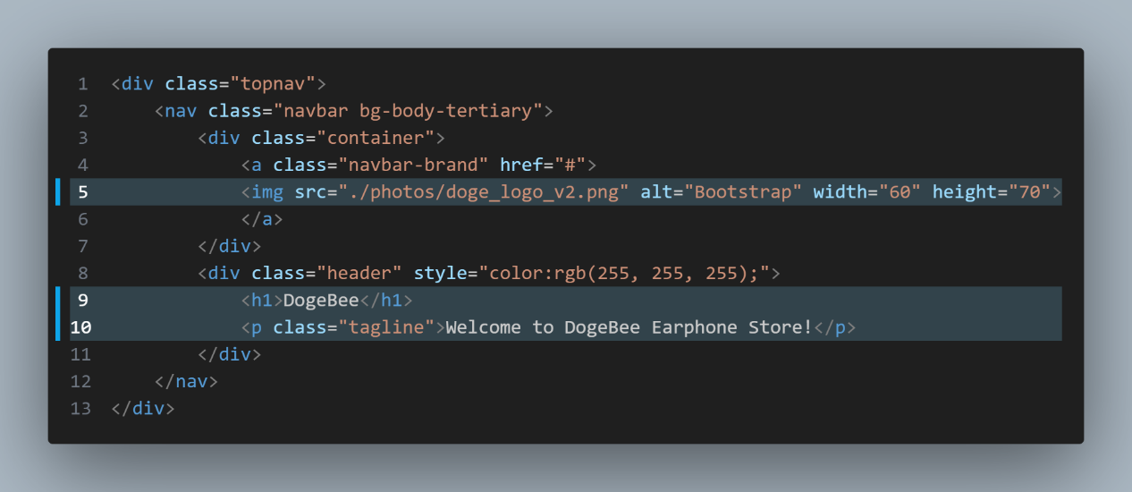

This allows the logo below to show by using <img src=”xxx.png”> pattern.

The <h1> and <p> are showing the store name and the welcoming sentence.

一張含有 文字, 螢幕擷取畫面, 軟體, 陳列 的圖片

AI 產生的內容可能不正確。CSS:

display: inline-block; does not add a line-break after the element, so the element can sit next to other elements.

It allows you to set width and height on the element, in the code it is set as height:72px; and width: auto;.

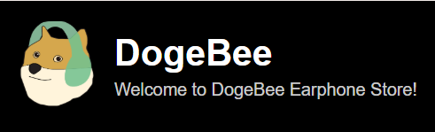

Effect:

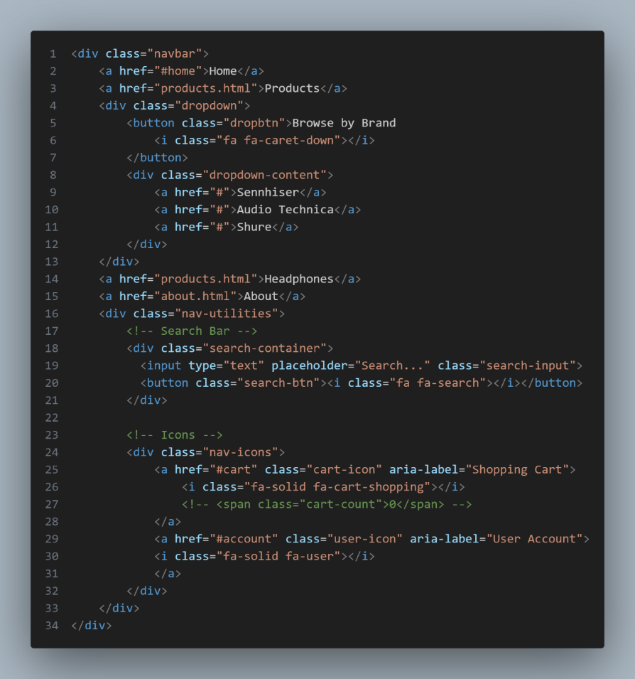HTML of Navigation Bar:

There are buttons for the Home page, products page, a dropdown list for browsing all the brands, a search bar, cart and user icon.

All the buttons are grouped by a CSS called search-container, it plays a part in aligning all the elements in a line.

Effect:



The dropdown menu of *Browse by Brand* button

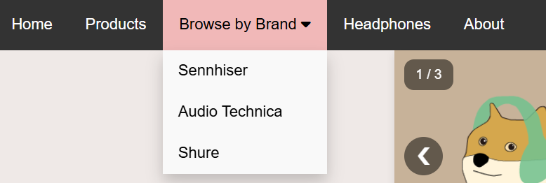

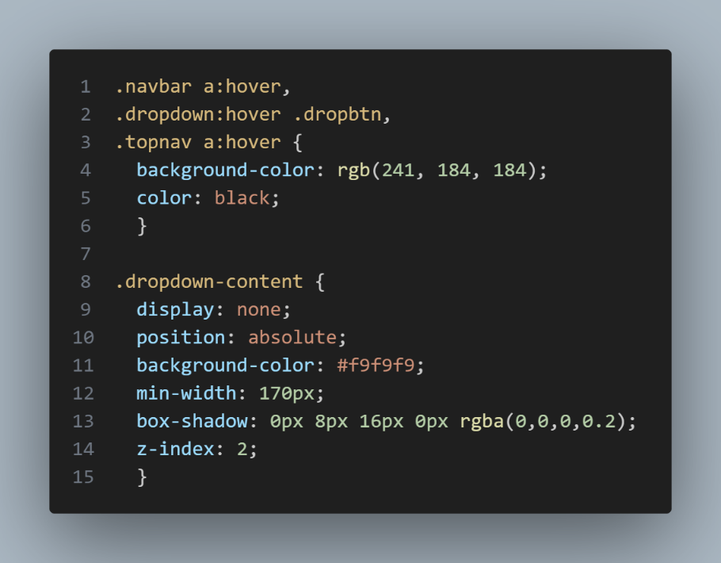CSS:

The buttons in navigation bar will change their text and background colour when the user hovers the curser shown as above.

The origianal text and background colour are white and dark grey respectively, the text and background colour changed to black and light pink after hovering.

Slideshow (by external JavaScript file; .js)

The variable slideIndex is to change the index of the slideshow (picture)

一張含有 文字, 電子產品, 螢幕擷取畫面, 陳列 的圖片

AI 產生的內容可能不正確。

The startSlideShow() function is for calling the for loop to encounter the operation of slideshow. It changes the slideshow 5 seconds per slide, user can move the slideshow on their own too by the function plusSlides().

HTML: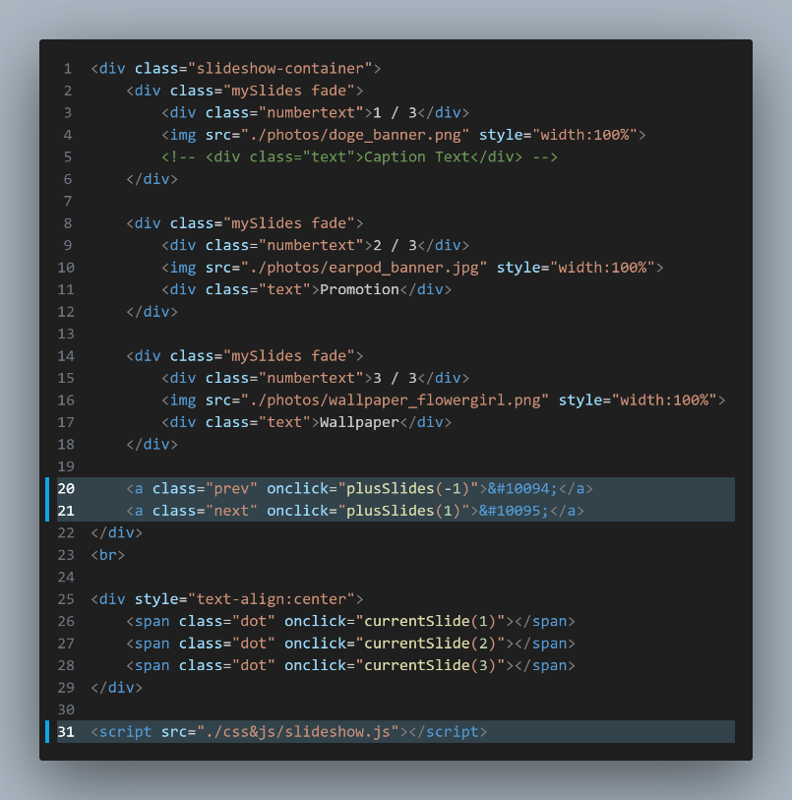

<script> </script> is to link to the javascript at the right side.

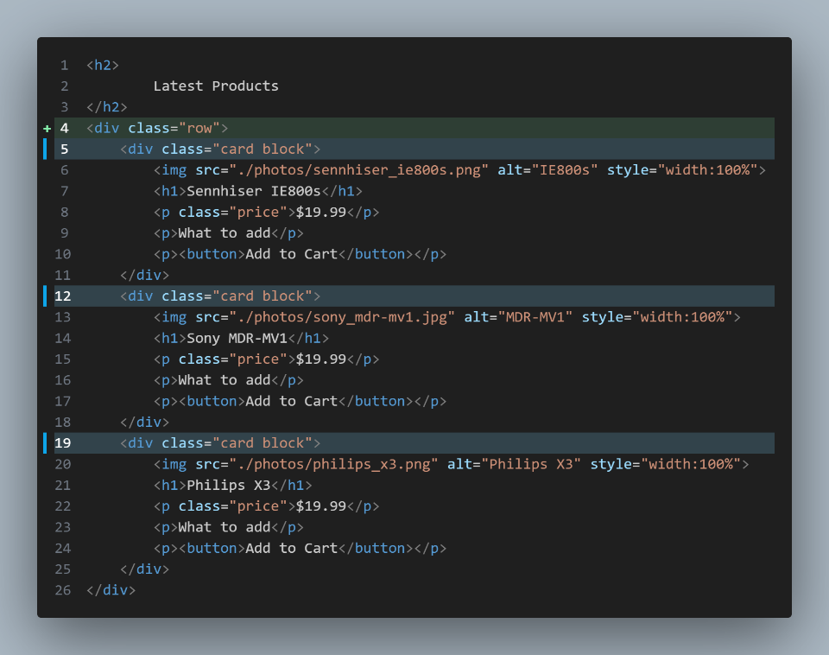HTML of product cards located at the latest product session:

The css .row is to group the product cards below in order to stay in a horizontal alignment, and the .block is to set the width of each product card.

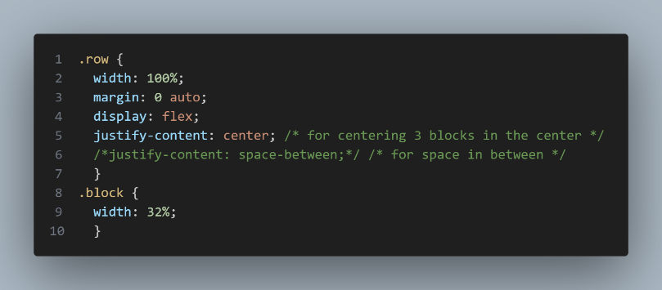

一張含有 文字, 頭戴式耳機, 音訊設備, 電子裝置 的圖片

AI 產生的內容可能不正確。The product card will shift up a bit and add a shadow effect when user hovers on it.

It is done by the css below.

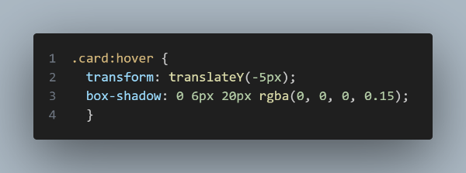

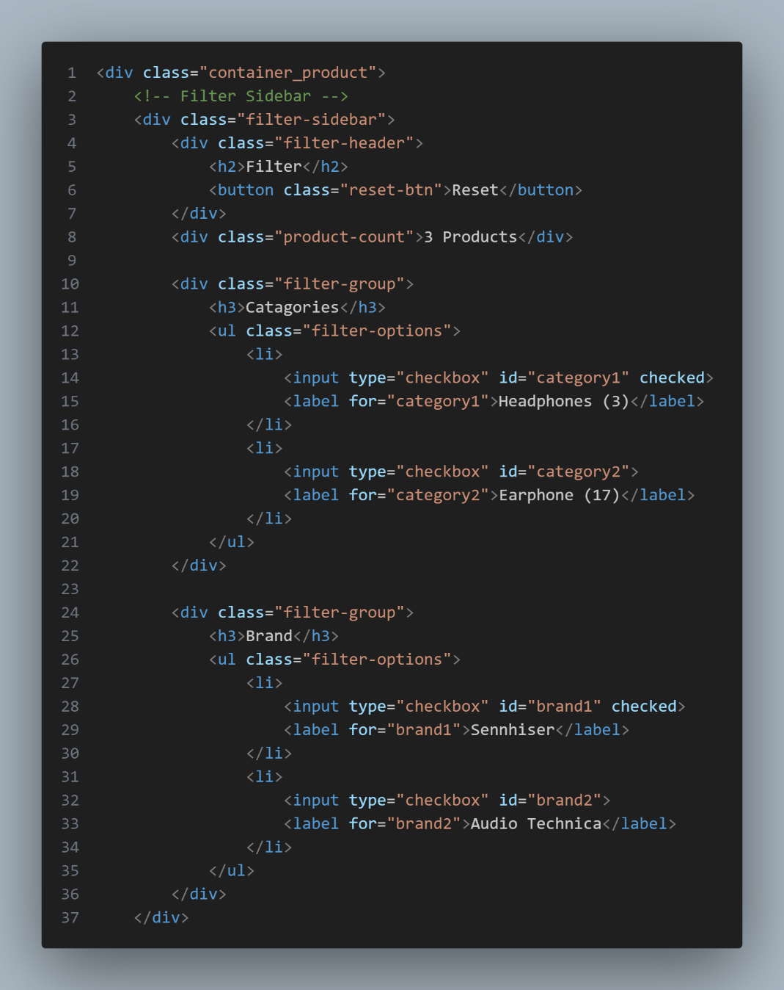Products Page

Products filter:

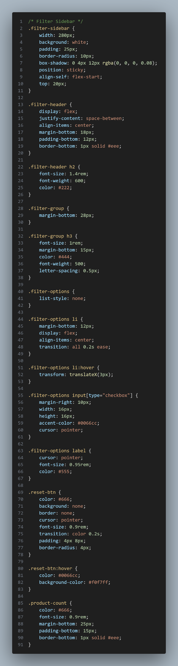This is the code of the products filtering side bar.

一張含有 文字, 螢幕擷取畫面, 字型, 數字 的圖片

AI 產生的內容可能不正確。Effect:

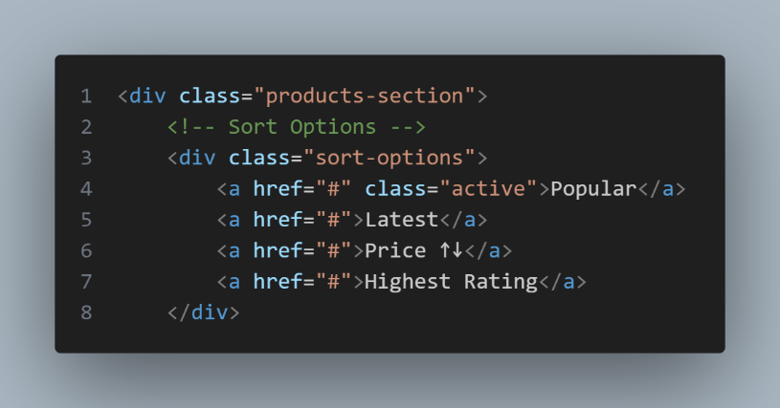Products Sorting:

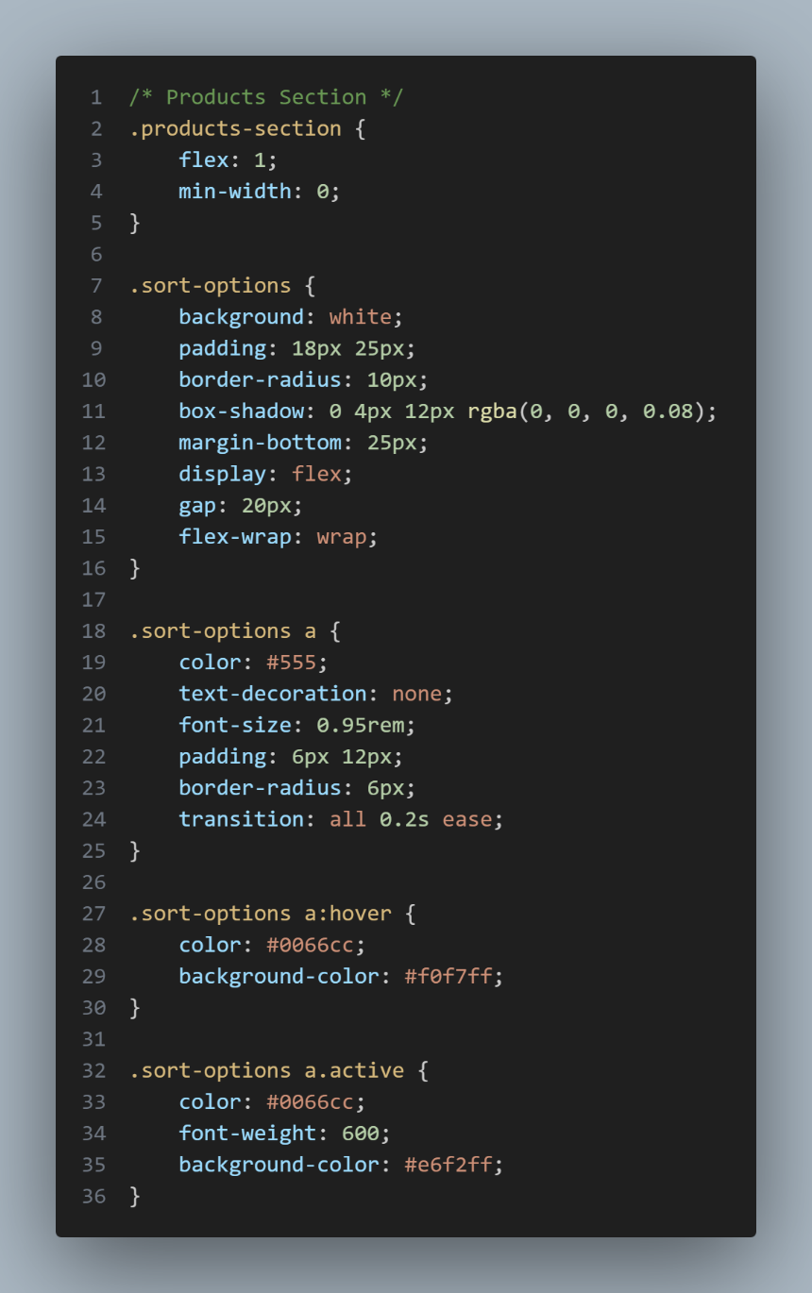HTML: CSS:

Effect: